**GROCERY MANAGEMENT SYSTEM**

**BY**

**Aashish Bhandari**

**8262/17**

St. Xavier’s College

A Summer Project Report Submitted to

**Faculty of Management, Tribhuvan University**

In partial fulfillment of the requirements for the degree of

**Bachelor of Information Management**

Kathmandu, Nepal

February, 2021

# STUDENT DECLARATION

This is to certify that I have completed the Summer Project entitled “Grocery Management System” under the guidance of “Bal Krishna Subedi” in partial fulfillment of the requirements for the degree of **Bachelor of Information Management at Faculty of Management, Tribhuvan University.** This is my original work and I have not submitted it earlier elsewhere.

Date: 2021/02/25 Signature:

Name: Aashish Bhandari

# CERTIFICATE FROM THE SUPERVISOR

This is to certify that the summer project entitled Grocery Management System is an academic work done by Aashish Bhandari Submitted in the partial fulfillment of the requirements for the degree of **Bachelor of Information Management** at faculty of Management, Tribhuvan University under my guidance and supervision. To the best of my knowledge, the information presented by him in the summer project report has not been submitted earlier.

______________________

Signature of the Supervisor

Name

Designation

Date

# ACKNOWLEDGMENT

First of all, I would like to thank **Tribhuvan University** for providing us with such a wonderful platform for us to grow and thrive. Along with that, I am very thankful for our college, **St. Xavier’s College**, for providing me with this wonderful opportunity. I am thankful for the Grocery store nearby my house for supporting me the project.

I would like to express my heartfelt gratitude and admiration to all those who immensely provided us the guidance and the assistance to complete the project. I would like to extend my special gratitude to our Head of Department, **Mr. Ganesh Yogi**, for his guidance during this project and also for his mentoring.

Furthermore, I would like to thank our project supervisor **Mr. Bal Krishna Subedi**, St. Xavier’s College for providing us valuable guidelines, supervision and suggestions to successfully complete this project. The success and final outcome of this project required a lot of guidance and assistance from many people and we are very fortunate to have this all along the completion of this project.

At last, I would like to express my sincere thanks to all my friends and colleagues who helped me directly or indirectly during the project time.

**Aashish Bhandari**

**(TU Exam Roll No. 8262/17)**

# EXECUTIVE SUMMARY

One of the most essential businesses throughout the century is the grocery business. Grocery stores are truly hallmark of the established society. We cannot hoard everything that we need or might require in the future, so we have grocery stores nearby to buy the items we require in day to day business.

Providing services to customers should be reliable, highly managed and should avoid a possible human error that is due to the existing manual system. One of the main problems of grocery stores while using manual systems is to keep error free records such as inventory, invoices, credits of customers etc. During a small survey at a local grocery store I came to know that people are willing to use systems that can automatically maintain inventory, credit system and billing.

Grocery shop management systems can lead to error free, secure, reliable and fast management systems. It can assist the user to concentrate on their other activities rather than focusing on record keeping. This system gives a summary of vital information such as total sales, total purchases, total receivable and total payable. Grocery stores can organize and maintain records without worrying about redundant entries and one need not to be distracted by information that is not relevant, while being able to reach the information.

# 

# LIST OF FIGURES

Figure 1 Current purchase flow. 2

Figure 2 Current Sales record flow 2

Figure 3 Agile method 5

Figure 4 Iterative Prototyping Model 6

Figure 5 Activity Diagram of Grocery Management System 8

Figure 6 Purchase System Flowchart 8

Figure 7 Invoice Flowchart 9

Figure 8 Architectural Design for web application 10

Figure 9 MVC Pattern 10

Figure 10 Context Diagram 11

Figure 11 Grocery Data Flow Diagram 12

Figure 12 Use case Diagram 13

Figure 13 Testing 14

Figure 14 Validation Login Form 15

Figure 15 Wrong credentials validation 15

Figure 16 Empty Purchase Table 16

Figure 17 Login protected route 16

Figure 18 Login Protected Route 17

Figure 19 Page not found 17

Figure 20 Purchase List Table 18

Figure 21 Vendor List Table 19

Figure 22 Inventory List Table 19

Figure 23 Purchase List Table 20

Figure 24 Inventory List Table. 20

Figure 25 Vendor List table 21

Figure 26 New Sales record 21

Figure 27 Updated inventory 22

Figure 28 Customer list 22

# LIST OF TABLES

Table 1 System Requirement 4

Table 2 Functional Requirement 7

# TABLE OF CONTENTS

STUDENT DECLARATION ii

CERTIFICATE FROM THE SUPERVISOR iii

ACKNOWLEDGMENT iv

EXECUTIVE SUMMARY v

LIST OF FIGURES vi

LIST OF TABLES vi

TABLE OF CONTENTS vii

CHAPTER I: INTRODUCTION 1

1.1 Background 1

1.2 Introduction to Organization 1

1.3 Current Situation of Organization 1

1.4 Issues/Problems of the report 2

1.5 Objective of the report 2

1.6 Methodology/Procedure adopted for the report. 3

1.6.1 Project Structure 3

1.6.2 Data and Information 3

1.6.3 Tools Used 3

1.6.4 Techniques for project report Analysis 4

1.6.5 System Requirement 4

CHAPTER II: TASKS AND ACTIVITES PERFORMED 5

Analysis of Task, Activities, Problem, Issues 5

Analysis of Tasks 5

Problems and Issues 5

Tasks Performed 5

Analysis of possible solutions 6

Requirement Gathering 6

System Design 7

System Activity Diagram 7

System Flowchart for Storing Purchase Record 8

System Flowchart for Storing invoice Record 9

Architectural Design 10

MVC Pattern 10

Context Diagram 11

Data Flow Diagram 12

Use Case Diagram 13

Testing 14

Unit Testing 14

# CHAPTER I: INTRODUCTION

## 1.1 Background

This project “Grocery Management System” provides a simple UI to maintain the different record of grocery inventory, purchase, suppliers and helps to track revenue, purchase etc. The first activity is to add purchased item with purchase rate and sales rate. This authority is given only to admin (administrator). As customer buys the products and comes to the billing counter, the user is supposed to enter the item name he purchased and the quantity of the item he had purchased. This is simple input from user side that does not involve much effort. The application is reduced as much as possible to avoid errors while entering the data. It also provides error message while entering the invalid data. No formal technical knowledge is needed to get familiar with this system.

Every organization, whether big or small, has challenges to overcome and managing the information of product, customer, stock, suppliers. With this system it is very easy to manage that information and also helps to analysis information by showing purchase trends and sales trends.

In local level grocery tends to manage credits for their regular customer in manual system and sometimes due to manual system errors and inaccuracy the relation between customer and grocery store becomes worse. This system provides small feature to avoid such difficulty and errors.

## 1.2 Introduction to Organization

Balkot Grocery is the small grocery store in my locality that provides essential services to more than 100 customers in which more than 30 of them are regular customer. Family started this grocery business in 2017 A.D with the primary aim of providing essential goods and services that is needed by every household in daily basis. They aim to provide good services to customer including credit facilities to regular customer. This store provides regular services to customer such as goods that is needed in regular basis like salt, sugar, food oil, other different product to more than 100 customers. It has becomes one of the essential entity of that locality.

## 1.3 Current Situation of Organization

After the establishment of the grocery store in 2017 A.D it has provides an important service that is needed in daily basics. Now a day due to increase in household in Balkot there are many customer that get services from this grocery store which ultimately increase transaction in this store such as purchase, sales, credit transactions etc. Currently they use register to record every purchase record as well as sales report. Keeping track of much customer credit is also maintained manually in register. Now a day due to increase in transaction to store there is inconsistency in data, rooms for errors. The overall system of grocery system is depending on single person which increase the probability of errors in data entry.

They heavily relied on traditional way of management of products and different transactions that occurred on grocery store. They use pen and copy to record different product on the inventory and updating inventory. With this manual system it has becomes very difficult to know which item is about to finished in the stock and which item to purchase from vendor. Precisely there is no any systematic way of managing inventory, keeping track of every product in the store.

The purchase flow currently in practice in this sore is shown in figure below.



Figure 1 Current purchase flow.

Sales flow currently in practice in this store is shown in figure below.

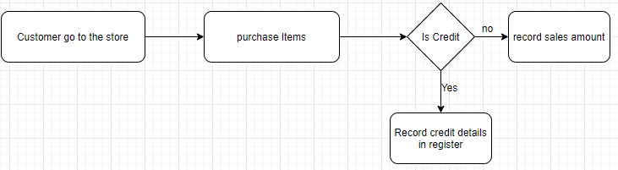

Figure 2 Current Sales record flow

Currently keeping record of purchase and sales is manual and it is very difficult to manage those records on long term. With purchase and sales it is very difficult to update inventory in manual system so currently inventory is calculated before purchase is made and there is high changes of purchasing less important item while there exists some item which needed to be purchase immediately.

## 1.4 Issues/Problems of the report

The issues/problems of the report are as follows:

* The project was not tested in real time data and traffics.
* Dummy data was used for verification and validation.
* Inability of local server to be up at all time.

## 1.5 Objective of the report

The main objective is to upgrading from traditional systems to modern one. Upgrading is needed in grocery store as it goes big day by day and customer increase. The other objectives of this report are:

* To computerize all main activities occurs in grocery store such as securely storing various transactions that occur in day to day basic in grocery without worrying about data loss; avoid human errors in calculations of transactions and making invoices.
* Maintaining customer’s details, invoices, credit, purchase and suppliers of the store and also store those data securely on database with both read and write operation by admin.
* For maintaining records of inventory in which products in inventory increase on every purchase and decrease on every sale automatically.
* Display revenue of grocery on daily, weekly and monthly basis.
* Display top demanded goods and products on grocery on weekly and monthly basis.

## 1.6 Methodology/Procedure adopted for the report.

### 1.6.1 Project Structure

A project needs a strong project structure to run smoothly, on schedule and deliver great results. The combination of these processes is the project structure used:

1. Planning: A proper plan was made before starting this project which involves breaking down project into manageable tasks throughout the semester.
2. Implementation: The plan was implemented properly with small modification.
3. Control: While doing this project adjustment of plan was made for proper implementation of plans.
4. Monitoring: Project was checked from time to time.
5. Termination: At last with planning, controlling all task was completed.

### 1.6.2 Data and Information

The data and information are very important part for every project. With analysis of data we know requirement of the system, study system feasibility such as technical feasibility. To collect data following method were applied:

1. Primary Data Collection: Data is directly collected from grocery Balkot Grocery which helps to know various problems and helps to know what should system consists to solve those problem.
2. Secondary Data Collection: Secondary data is collected to know further common grocery problem and way to solve those using websites, articles etc.

### 1.6.3 Tools Used

The following tools were used for completion of this system.

1. **Node.js:** Node.js is an open source, cross-platform and backend JavaScript run time environment which executes JavaScript code outside web browser. It is widely used now a day for web development.
2. **Visual Studio Code:** Visual studio code is a freeware source-code editor made by Microsoft for window, Linux and macOS. It is very helpful for writing system code having several features like syntax highlighting, intelligent code etc.
3. **MongoDB:** MongoDB is document-oriented database program. I will be using this for storing various data because it is great when data structure is going to change over time to time as it is schema-less database.
4. **Express.js:** This is Node.js web application framework. I will be using express for backend as it is very easy to configure for API based project and easy to integrate NoSQL database like MongoDB which will be used as database in this project.
5. **Github:** Github is a web base services which helps to store code based on version control tool like Git.
6. **Git:** It is version control tool used for various software development applications. It tracks the changes made in various files and can be reverted to specific version of the project when needed.
7. **Microsoft Word:** Microsoft word is the most popular word processing system and justifiably. It is easy to use and allow you to create all the different types of documents. Here, Microsoft word is used to write project report.
8. **draw.io:** This is web based application which helps to draw diagram which is widely used in this project.
9. **Creately:** This is also a web based application like draw.io to make class diagram which is used in this project.

### 1.6.4 Techniques for project report Analysis

For analysis of project report, observation was used as the main technique. Other techniques that were used are:

* Internet Search
* Interviews
* Surveying with friends
* Showing to supervisors.

### 1.6.5 System Requirement

|  |  |
| --- | --- |
| Operating System | Windows 7 or Above |
| Internet Connection | At least 1 mbps |
| Browser | Any Browser |
| Device | Laptop/PC/Phone |

Table 1 System Requirement

# CHAPTER II: TASKS AND ACTIVITES PERFORMED

## Analysis of Task, Activities, Problem, Issues

Tasks and activities have been accessed, i.e. what needs to be done to obtain project objectives. Problems with the project are also critically analyzed in order to find future project improvements and flaws.

### Analysis of Tasks

The author visited grocery store nearby for requirement analysis and analysis of tasks. The main problem which is needed to be addressed is identified. After the collection of information, various analyses is done to make those collected information meaningful and address the main problem that is collected during this task. In this process problem and way to address problem in the system are analyzed in certain time frame for completion of summer project. Various problems are broken down into small problems which are easy to manage.

### Problems and Issues

After analysis of task and information obtained from data collections problem and issues of grocery store is addressed. Grocery store generally operates with huge transaction of purchase and sales and there were no modern way to efficiently manage those problems. Manually managing purchase and sales and no way of updating inventory on daily basis are major problem that was addresses during the survey and research.

Another problem that was also address was there is manual system of calculating revenue and purchase which might be inaccuracy.

### Tasks Performed

Following Tasks were performed during development of this project.

#### Selection of development methodology:

When it comes to handling tasks, there is no' one size fits all' strategy. This focuses on the project's complexity. The system includes the details and forms required for the efficient creation of the project along with the bird view of the project. I use the Agile Model. Agile approaches are incremental development methods of implementation in which the increments are minimal and new framework launches are usually created. The steps and principles of agile is not strictly followed, rather the strategy is made as much flexible and situation friendly as possible.

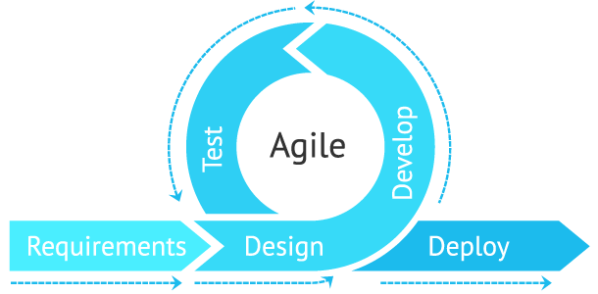

Figure 3 Agile method

The advantages of agile method are:

* + Implementation of changes in feature is easier.
  + Testing is done along with the development phase. So, minimum changes are required at the end of the project.
  + By breaking down the project into manageable units.

#### Development of Prototype:

Normally, actual requirement are known before we start with making product. There are many prototypes involving with software development. For this project iterative prototyping model is used. As name suggest it is repeating cycle of designing, prototyping, testing multiple version of the product until product is finally made. In traditional prototyping design we finalize the design before making the product where as in this approach we create working design, test it before finalizing and keep on changing until final design is made.

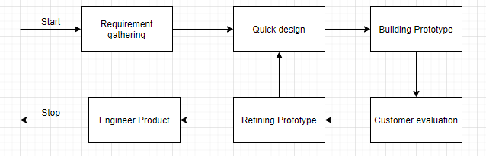

Figure 4 Iterative Prototyping Model

The reasons to choose this prototyping model for this project are:

* + Users are actively involved in the development.
  + A working model of the system is provided so the users get a better understanding of the system being developed.
  + In every prototype errors can be detected much earlier.
  + Quicker user feedback is available leading to better solutions.

#### Information gathering and analysis.

Another task performed was information gathering which was done by primary by visiting grocery store and secondary source by internet search, books, PDF etc. The gathered information is then analyzed and the domain of problem is determined.

## Analysis of possible solutions

### Requirement Gathering

The main objective of this stage is to identify and evaluate requirements of the proposed system. This stage aims to recognize the user requirement which may be both functional and nonfunctional requirement. Functional requirement defines a function which it must perform. Nonfunctional requirement defines system attributes like security, reliability, system performance in terms of space and time complexity, maintainability, scalable etc. Requirement gathering helps to know actual needs that system must have.

Functional requirement of this system is listed in table below.

|  |  |  |
| --- | --- | --- |
| S.N | Functional Requirements | Use Case |
| 1 | Admin can login | Admin |
| 2 | Admin can insert purchase record | Admin |
| 3 | Admin can insert invoice record | Admin |
| 4 | Admin can update inventory. | Admin |
| 5 | With purchase record insert inventory is updated automatically | Admin |
| 6 | View Purchase report on daily, monthly basis or from the beginning. | Admin |
| 6 | View Sales report on daily, monthly basis or from the beginning | Admin |
| 7 | Maintain Vendor information. | Admin |

Table 2 Functional Requirement

The nonfunctional requirement of the system must contain following feature.

* The system should be secure
* The system should be responsive and fast.
* The system should be simple to use.
* The system should hold integrity of user information.

### System Design

System design is the process in which requirements of the system is converted in system modules or architecture i.e. converting business requirement to software components. According to Wikipedia Systems design is the process of defining the architecture, modules, interface, and data for a system to satisfy specified requirements. Systems design could be seen as the application of systems theory to product development.

### System Activity Diagram

Activity diagram represent overall activity of a system. It visually presents a series of actions or flow of control in a system. They are similar to flow diagram but it represents system flow better than flow diagram. They are often used in business process modeling. They are also used by developer to figure out the overall flow of the system in high level.

Activity diagram is very useful in this project with the following reasons.

* It helps to identify use case flow and overall system flow and find weakness or loopholes that may be present in this system.
* It helps to identify pre and post conditions for use case in this project.

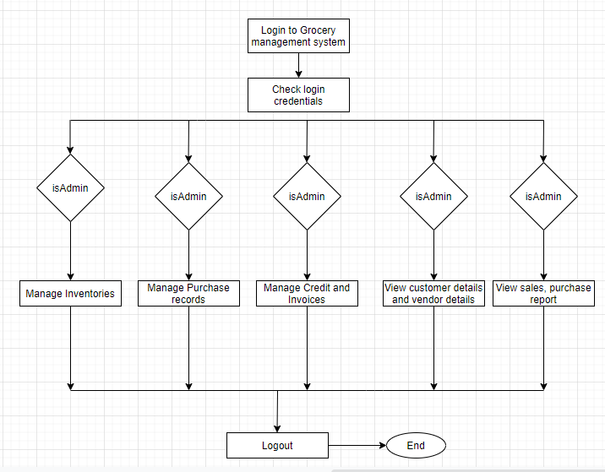

Figure 5 Activity Diagram of Grocery Management System

### System Flowchart for Storing Purchase Record

The flowchart below shows that how inserting purchase data work on the system.

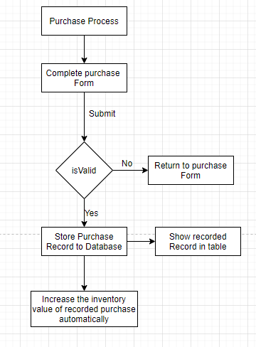

Figure 6 Purchase System Flowchart

Here first of all user need to insert purchase item in the grocery management system. If user submit invalid data to the purchase form it will stay on same page showing the errors to the users. If everything went right then it insert purchase record in the database and automatically update inventory of that inserted purchase item.

### System Flowchart for Storing invoice Record

Here flowchart below show how invoice record keeping system works and the effect on inventory.



Figure 7 Invoice Flowchart

Here invoices are recorded after sales have been completed in the store. After sales the sales item is recorded in the system for future report and performances analysis. When sales invoices are recorded in the system first it checks the provided data by user is valid or not. If data is not valid system stays on the same page with error message. If there are no errors then system record invoice data into database and reduce inventory item that was sold.

### Architectural Design

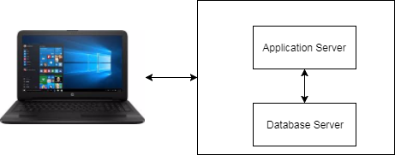

Figure 8 Architectural Design for web application

Here to complete grocery store management system client server architecture is used for obvious reasons. The database server is MongoDB which is chosen for its flexibility for storing unstructured data and provides enough capacity for storing many data. For application server author uses node.js version 12.13.1 as server side scripting language. Client is any web browser that can be of any version.

### MVC Pattern

It is a very common and rational architecture pattern for server side programming that the author prefers MVC patterns. MVC pattern represent separate logic for data, application logic and User interface. With changes in any one of the component other component does not changes due to which it is very easy to manage code and maintain application in future if needed.

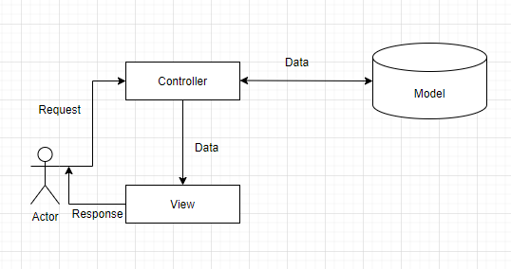

Figure 9 MVC Pattern

### Context Diagram

Context diagram is used to give an overview of an entire system. In a context diagram there is only one circle/process that represent the entire system. The purpose of this diagram is to display the excepting inputs and outputs from the system to and from various external entities. Through this display a system analyst can model what expected data is going to go into the system, and then after it has been processed by the system, it will show what information will be returning to the external entities.

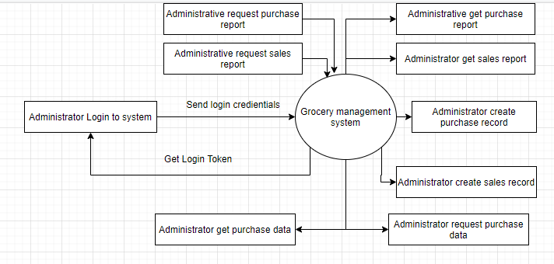

Figure 10 Context Diagram

The overview of the context diagram is shown above in which admin login to system using email and password and system gives unique token which is valid for only certain time so admin can login to system. Admin can create purchase record and view this purchase record. Admin also can create sales record and save it to invoice collections. With every purchase and sales actions that occurs in the system inventory is updated itself by the system.

### Data Flow Diagram

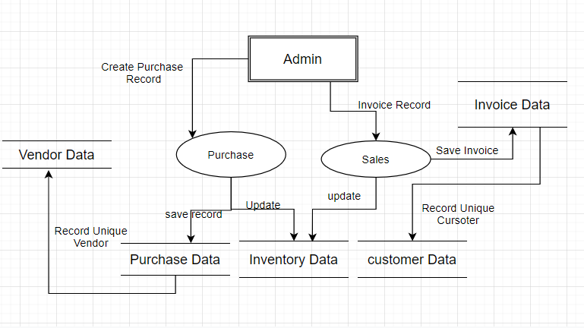

Figure 11 Grocery Data Flow Diagram

Data-flow diagram is a way of representing a flow of data through a process or a system. It provides information about the outputs and inputs of each entity and the process itself. In in the above diagram admin have all the privilege to create purchase record, sales records and manage inventory. However inventory is managed by purchase and sales event automatically. For some exceptional case admin can also manage inventory. Admin can input invoice related information in form and submit data to save to sales collections in database. After sales record is recorded in database inventory is updated to reduce sale item. While creating sales recorded if unique user is registered to system then it save new customer to customer collections in database.

When new purchase recorded is created inventory is updated to increased purchased product item. If new vendor is detected while inserting purchase record then vendor data is inserted into vendor collections.

### Use Case Diagram



Figure Use case Diagram

It is very difficult to know the entire requirement before starting developing specific system. The purpose of use case diagram is to capture the dynamic aspect of a system. It is used to know feature of the system.

New actors other than admin are customer and vendor which interact with the system. In the above use case diagram admin is grocery store and system admin can perform insertion of purchased goods, sold goods and create invoice. He can view grocery reports on the monthly, weekly and also whole life time of the grocery system. He can view which goods are being sold at alarming rate by looking at top demanded table generated by system based on entry of sales record. Vendor/supplier supply goods to grocery system which is also recorded by system.

### Testing

Testing is regarded as one of the most critical aspects of system design/architectures, but it is often ignored and executed partially.

Testing was not conducted by author in traditional way in which system testing is done after fully development of the system rather testing was performed iteratively as system was built which saves a lot of time. It helps to find lots of errors and bugs that system possesses and might causes the system to go to other direction that it was intended to.

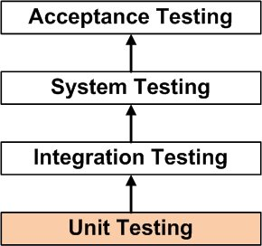

Figure Testing

### Unit Testing

In this testing method testing is done for each component in isolation. This testing is done after building small component of system to check if these components give expected result.

Unit testing is performed by the author on the individual units of source code with a goal of making used if units are working as it should. This type of testing is very important in a system as It contain so many components which are very important for overall working of the system.

If test fails or we get result that is not expected from the component then it is lot easier to maintain in this stage than finding after system is completed or in later stage.

Following unit testing cases were implemented:

**Test Case 1: Admin Login Validation.**

**Test Data:** Empty Form Data

**Expected outcome:** It prevents user to send request to server for login token.

**Evidence:**

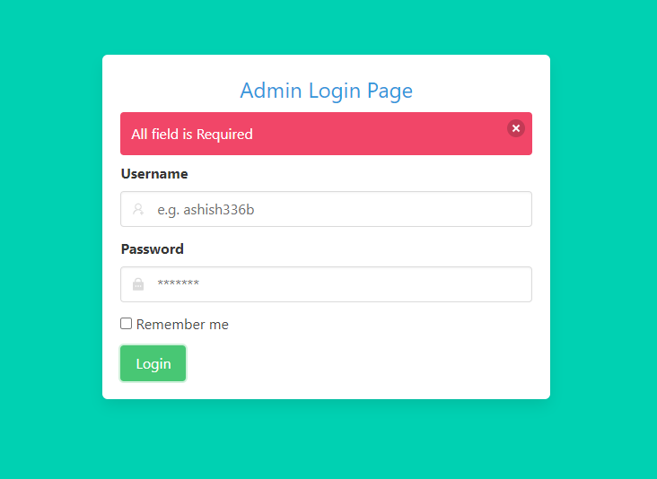

Figure Validation Login Form

Test case 2: If user enters wrong username or password.

Test Data: Wrong username and password.

Expected Outcome: Show error message stating username or password doesn’t match

Evidence:

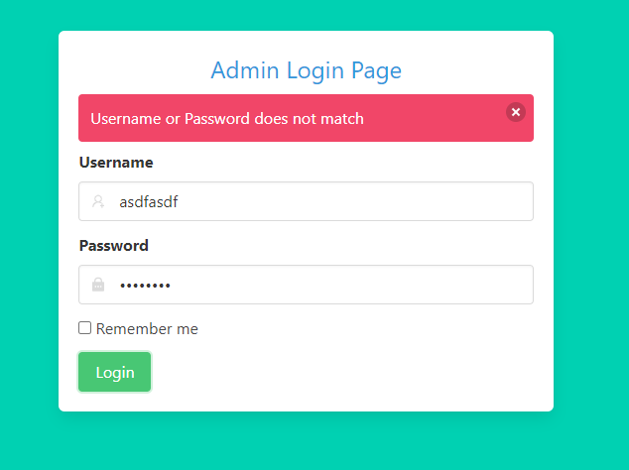

Figure Wrong credentials validation

Test case 3: If there are no purchase records.

Test Data: Empty form Data.

Expected outcome: Show No Data available in table.

Evidence:

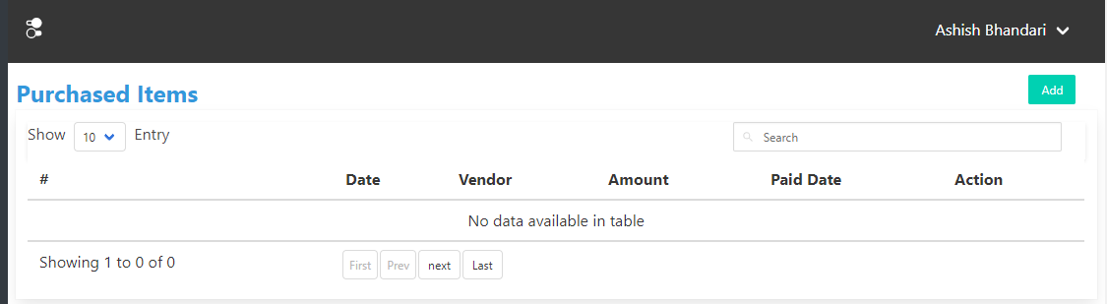

Figure Empty Purchase Table

Test case 4: If users send URL without login token that require login token from postman.

Test Data: Send request without token to login protected URL.

Expected outcome: Error message in JSON Format.

Evidence:

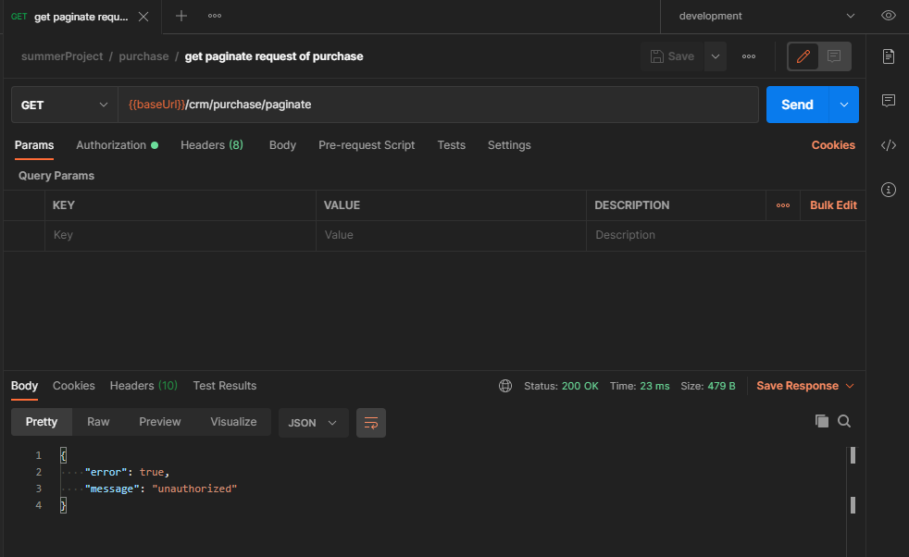

Figure Login protected route

Test case 5: If user want access to dashboard without login from web UI.

Test Data: Manually enter dashboard URL.

Expected outcome: System should redirect to login page.

Evidence:

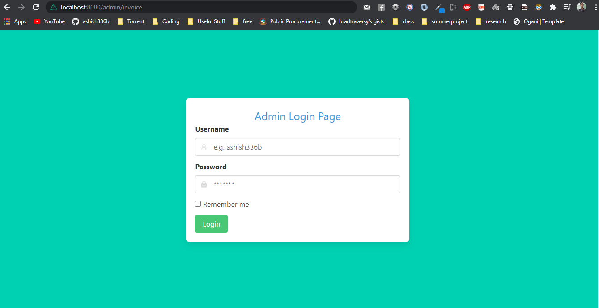

Figure Login Protected Route

Test case 6: If user manually type unregistered URL.

Test Data: random URL

Expected Outcome: Display “This page could not be found”

Evidence:

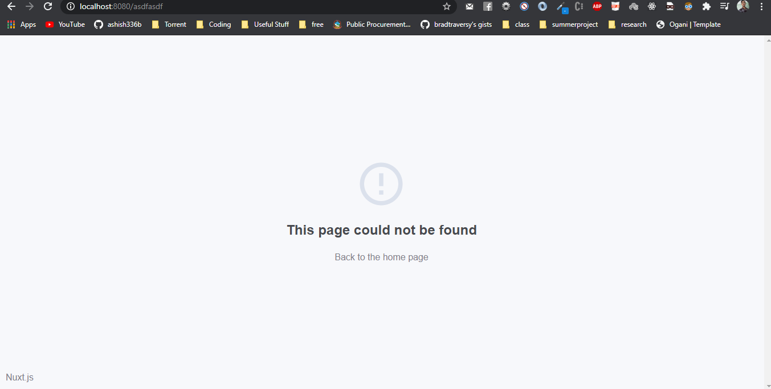

Figure Page not found

### Integration Testing

Integrated testing is defined as a type of testing where software modules are integrated logically and tested as a group. This type of testing consists of checking data flow from one module to another module when certain action is being done in the system. In this phase of testing two or more components are grouped together for testing.

Test Case: Create new purchase record

Test Data: Every purchase details mentioned in form field.

Expected outcome: If purchase record is created then it should update inventory automatically, if purchased from new vendor then new vendor details should be stored in database and purchase record should be listed in purchase table.

Evidence:

Before Creating Purchase Record

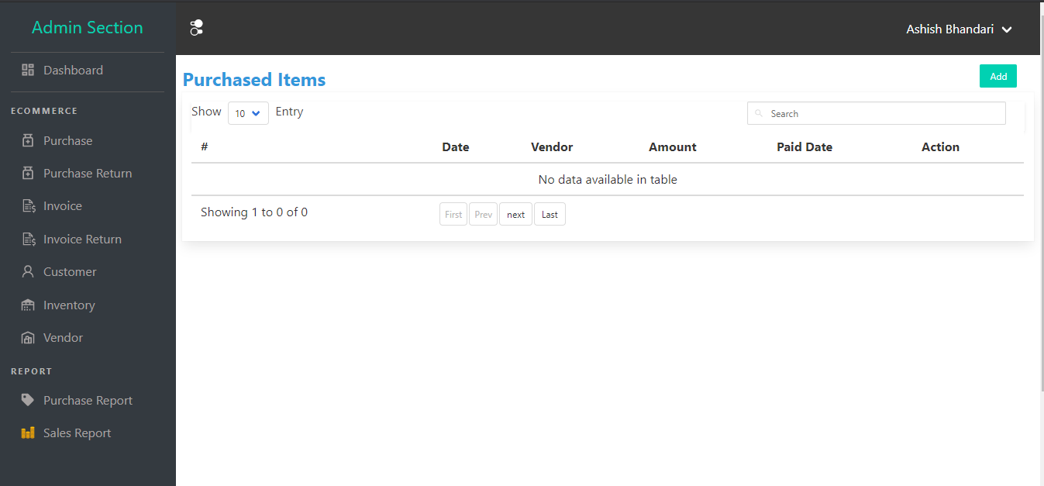

Figure 20 Purchase List Table

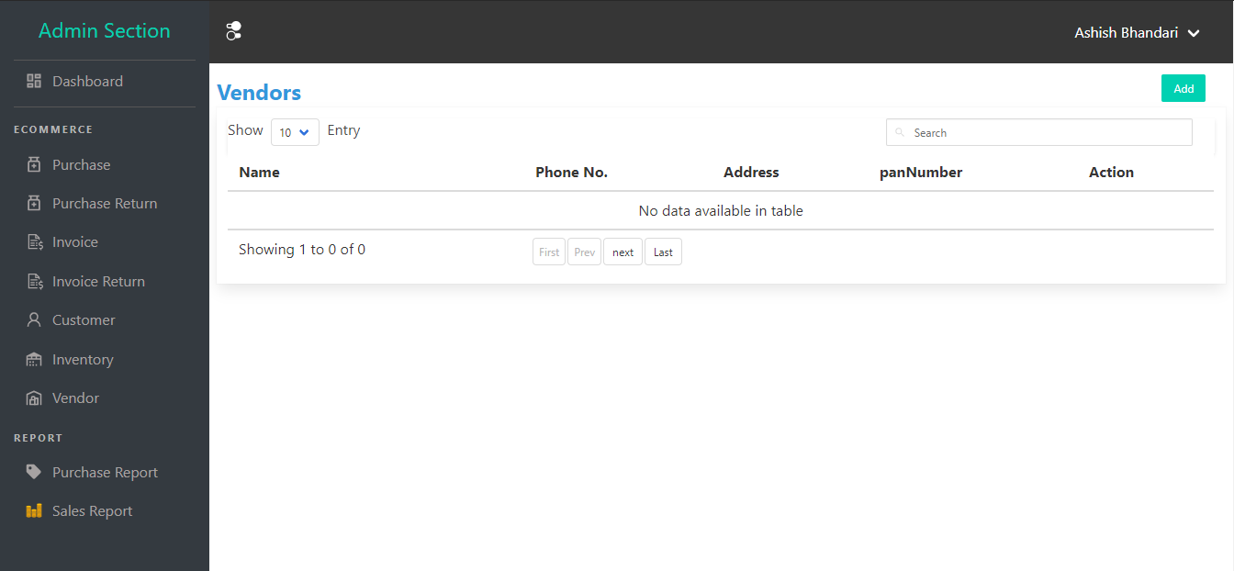

Figure 21 Vendor List Table

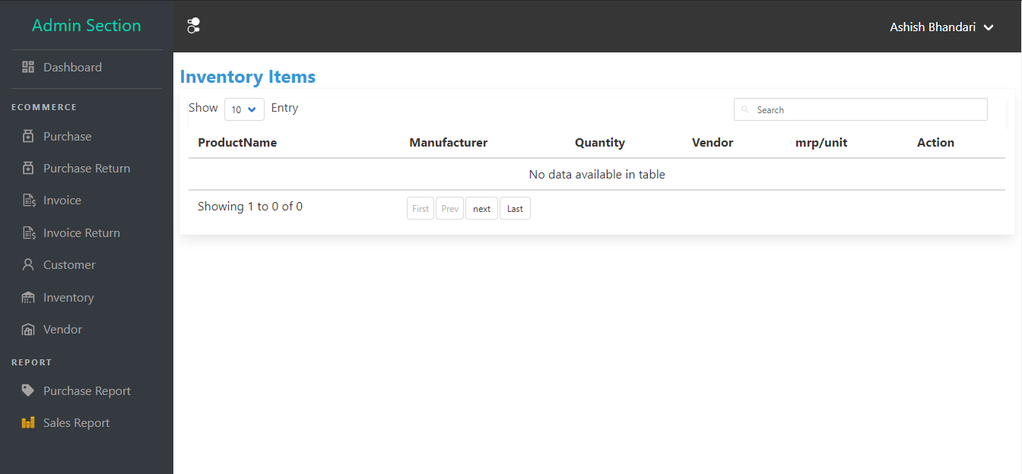

Figure 22 Inventory List Table

After Purchase record is created:

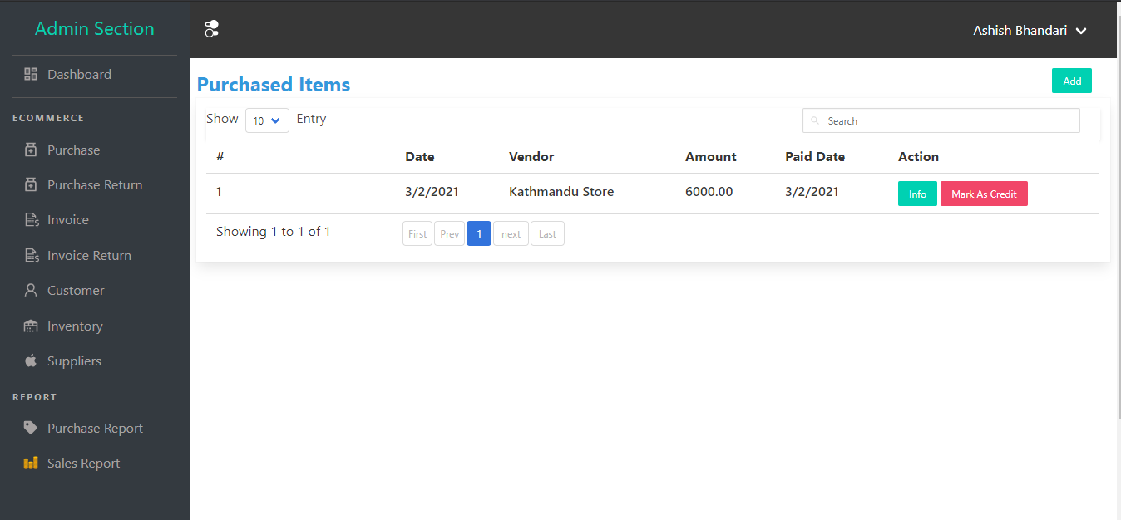

Figure 23 Purchase List Table

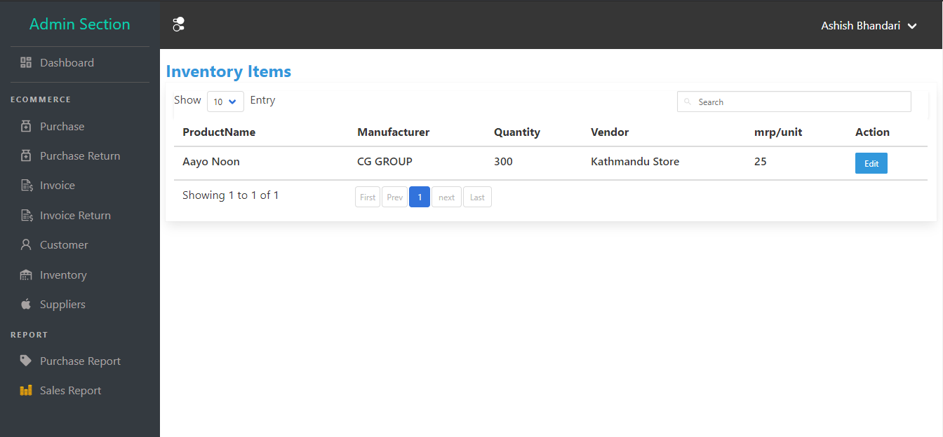

Figure 24 Inventory List Table.

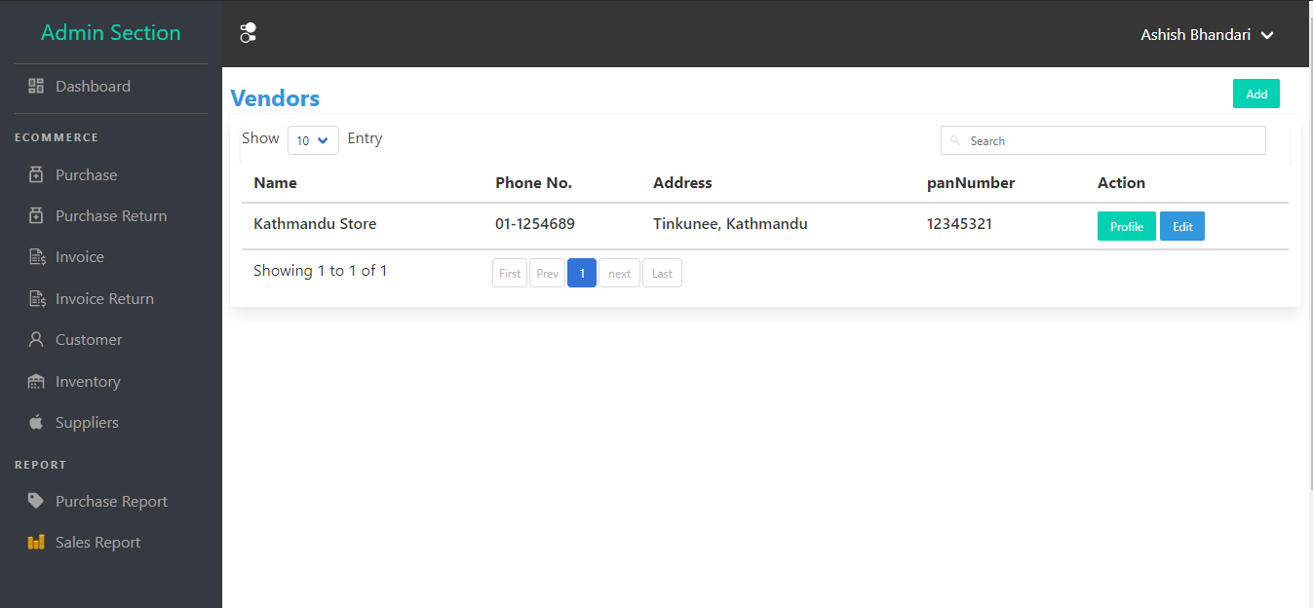

Figure 25 Vendor List table

Test case 8: Create new sales record.

Test Data: All required form data like customer details, product details, and grand total etc.

Expected output: When new invoice record is created, it is listed in invoice list, reduce quantity form inventory, and if new customer is recorded customer is recorded in database and listed on customer list.

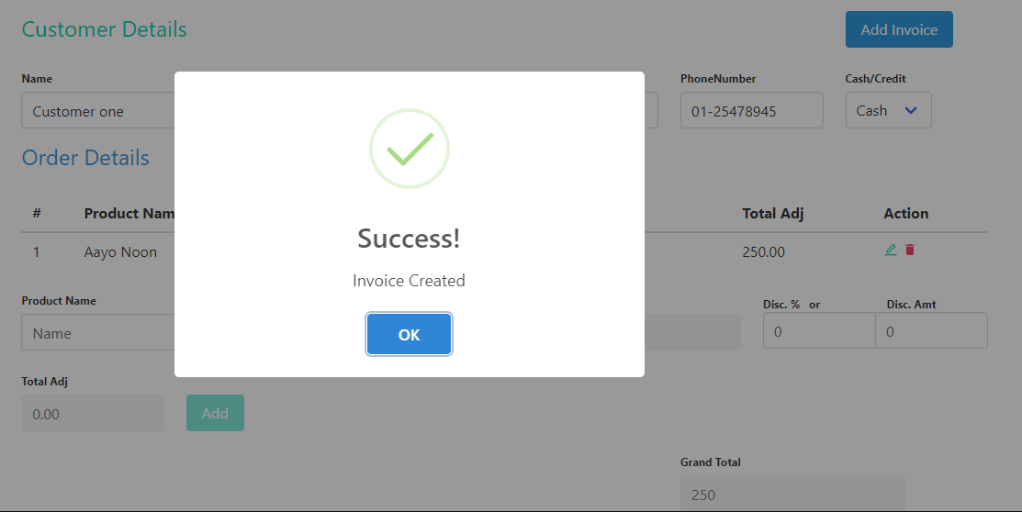

Figure 26 New Sales record

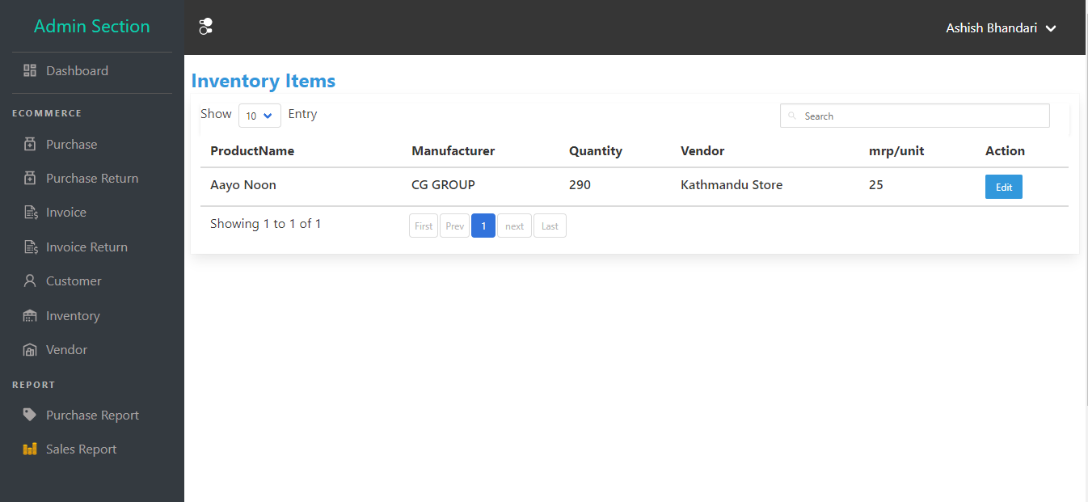

Figure 27 Updated inventory

Previously inventory quantity was 300 items and after 10 items is sold to customer inventory is updated to 290 item.

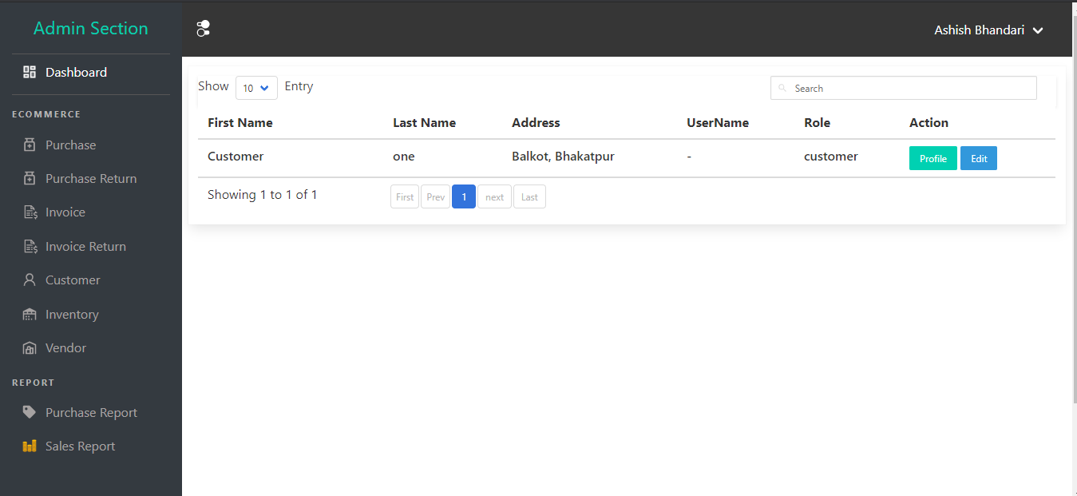

Figure 28 Customer list

Since new customer is detected by system and then it was recorded in database after sales is being complete.